**CDA Website – Animation Specification**

**Header**

On hover:

* Nav items are underlined with the same colour - see XD design for example
* 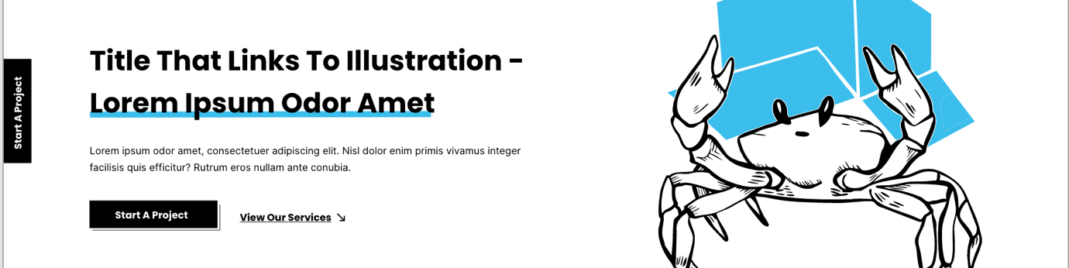Start a project sticky button on left hand side – subtle drop shadow on hover

**Buttons**

On hover:

* Filled in buttons become transparent
* Unfilled buttons become filled in
* Buttons with arrows – the arrow rotates towards direction of flow, forwards or back

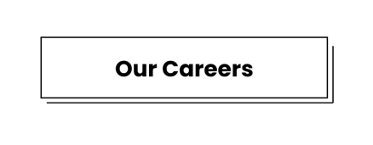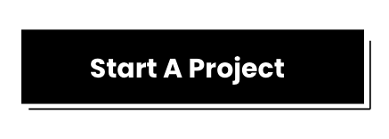

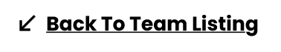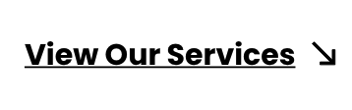

**Videos & Life at CDA**

On hover:

* Play icon follows mouse around – only over the video (similar to <https://wolffolins.com/>)
* 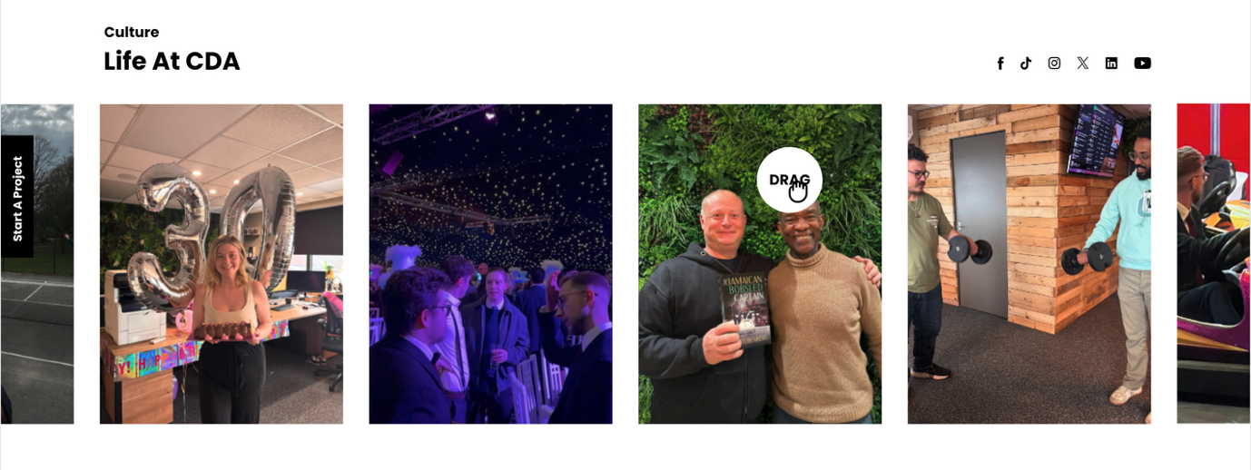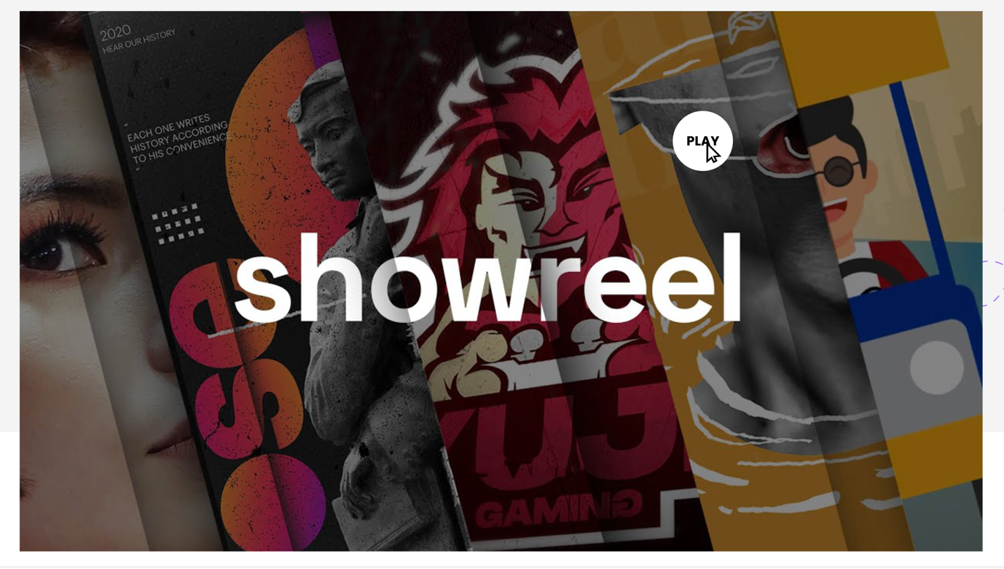Drag icon follows mouse around – only over the images (see here <https://www.zypsy.com/about>)

**Showcase video logos**

Slider:

* 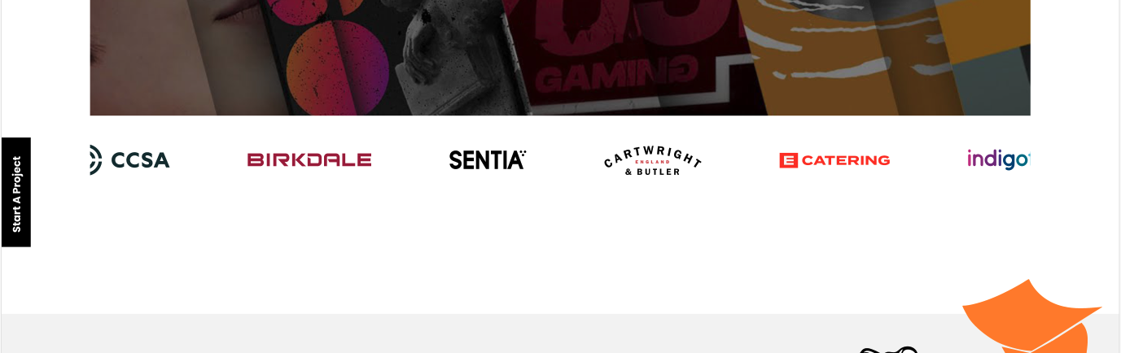Logos will be on a constantly moving slider – please match the speed with the “Partners who trust us” section on this website: <https://www.wolfpack-digital.com/>

**Case studies block**

Animation upon scroll to section:

* 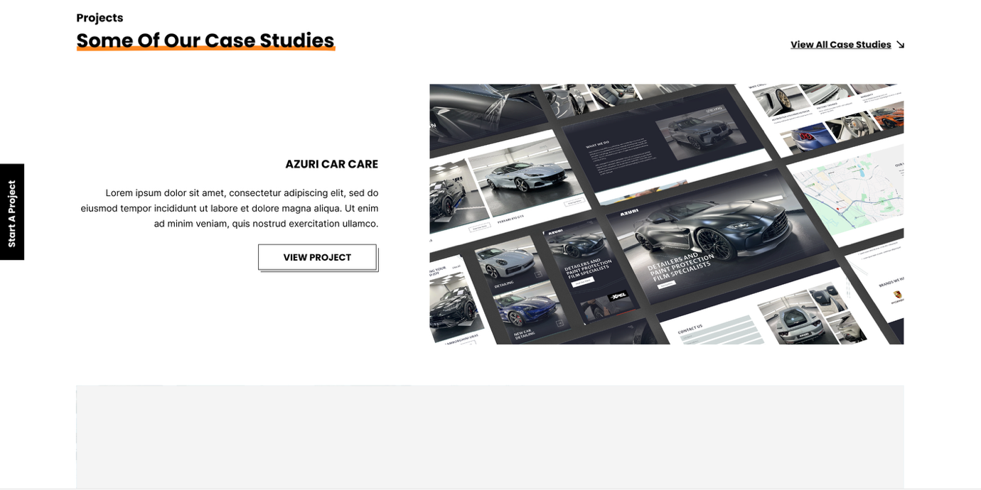A coloured section will scroll over the page to reveal the case studies below — similar to the animation on [Emperor Works](https://emperor.works/). I’ve created a rough example in the XD file: if you click the grey box, then the blue box beneath, you can see the animation stages. Please note, this is a simplified mock-up — the final animation should closely match the interaction and smoothness of the example on the Emperor site.

**Latest news / Insights**

On hover:

* 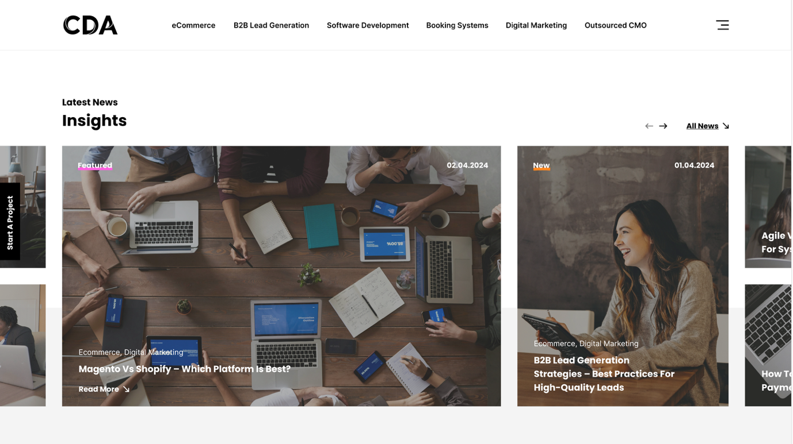Content will move up revealing the read more arrow – see XD design for example

**Footer**

On hover:

* When the user moves their cursor toward the 'Let’s Talk' button, a magnifying glass effect should animate over it. As the magnifying glass passes over the button, the button should scale up slightly to create the illusion of being magnified - see XD design for example.

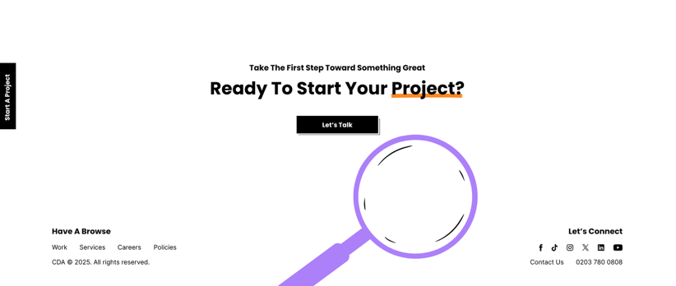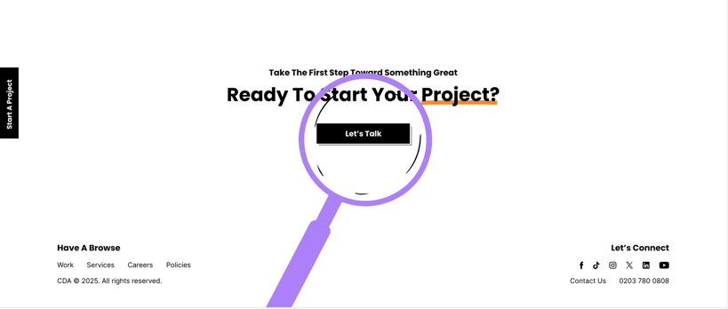

**Burger menu pop out**

On hover:

* 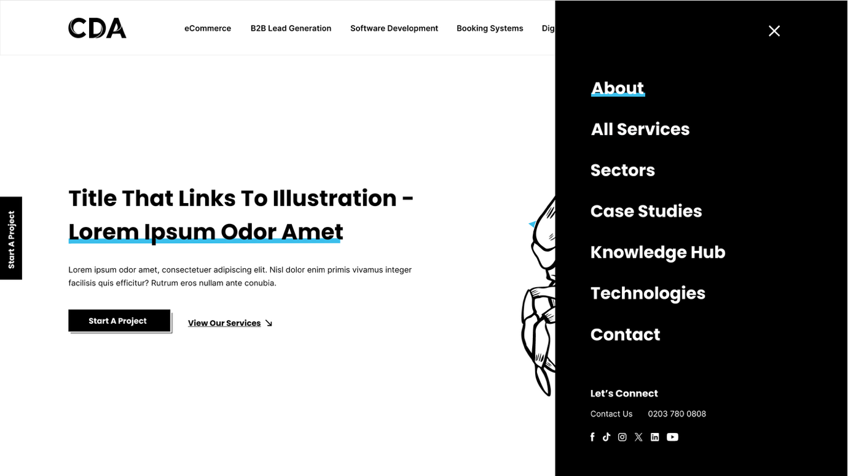Each nav item is underlined with the same colour upon hover - see XD design for example

**Services Landing**

On hover:

* 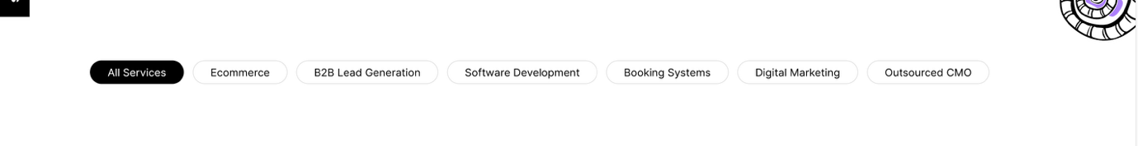Unfilled options become filled in - see XD design for example

On Scroll:

* Each service (ecommerce, B2B lead generation etc) is revealed with a colour transition – the same animation as the case study block and is see on [Emperor Works](https://emperor.works/). The transition colour will depend on the services – see below

Services colours:

* Ecommerce > Blue - #3CBEEB
* B2B lead generation > Purple - #AD80F9
* Software Development > Green - #01E486
* Booking Systems > Orange - #FD8721
* Digital Marketing > Pink - #FF60DF
* Outsourced CMO > Redish Pink - #FF5C8A
* AI > Blue - #3CBEEB

Please note each sub service e.g. Ecommerce Website Development within Ecommerce, should follow the same colour as the parent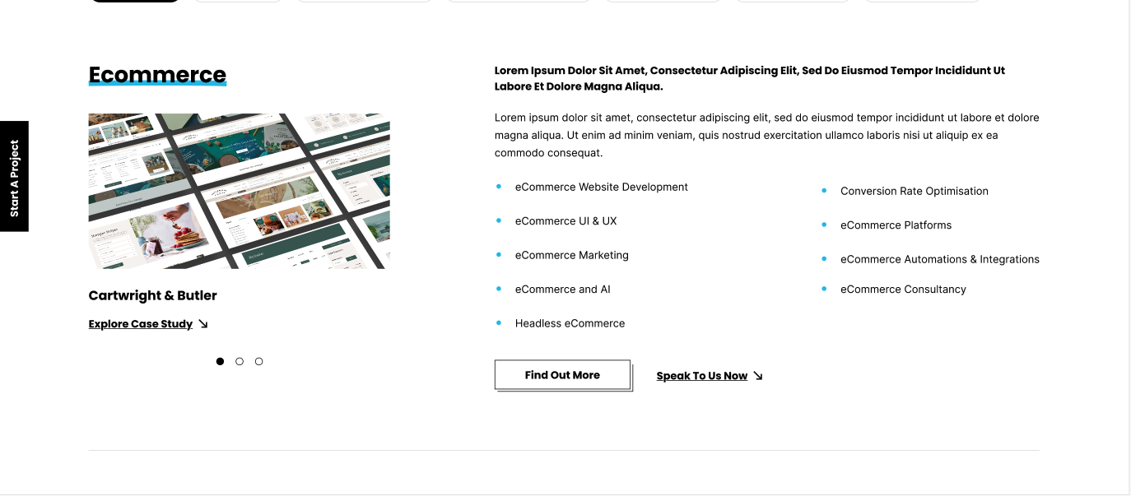.

**Service details page**

* All assets leading up to the 'Want to sell online' block should follow the colour scheme of their parent section — as shown in the design. For example, on the eCommerce page, these assets are blue, while on the Outsourced CMO page, the same assets use the reddish-pink colour.

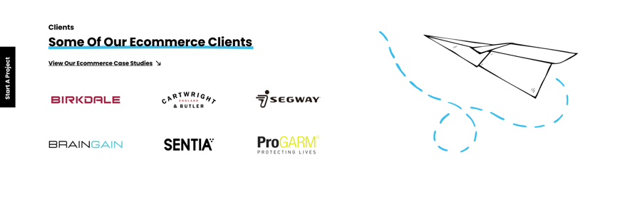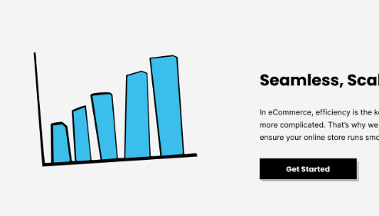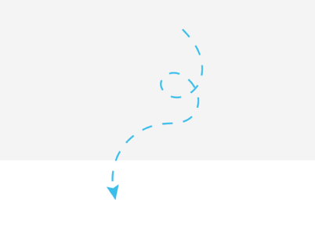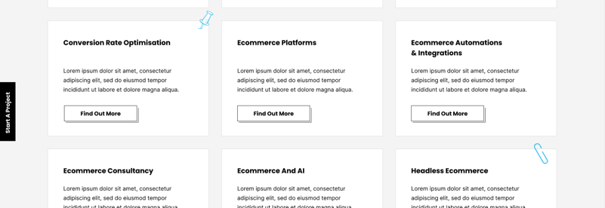

**Stats sections**

On scroll:

* 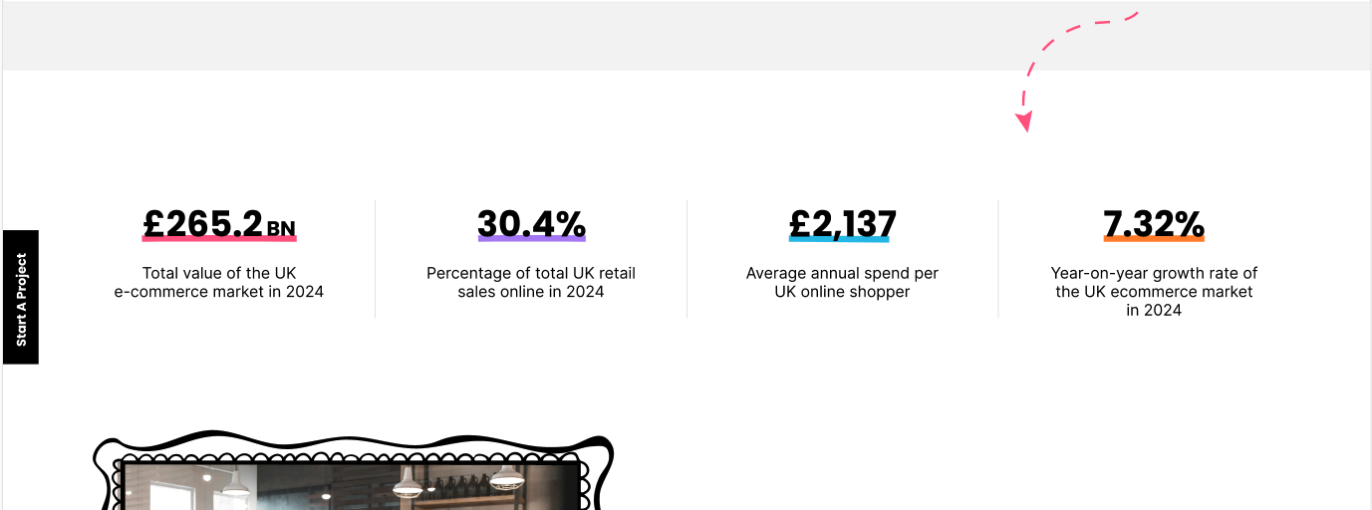For the stats sections that don’t include an illustration inside the block (example below), please animate a coloured line that draws left to right across the larger stat text. This line should appear one by one for each stat, in sequence, starting from the left hand side.

**Knowledge hub**

On hover

* 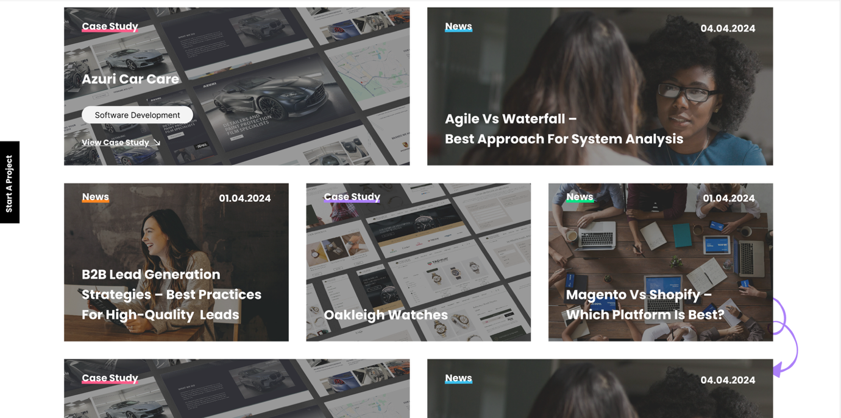Content scrolls up to reveal a read more button - see XD design for example

**Similar projects**

On hover

* 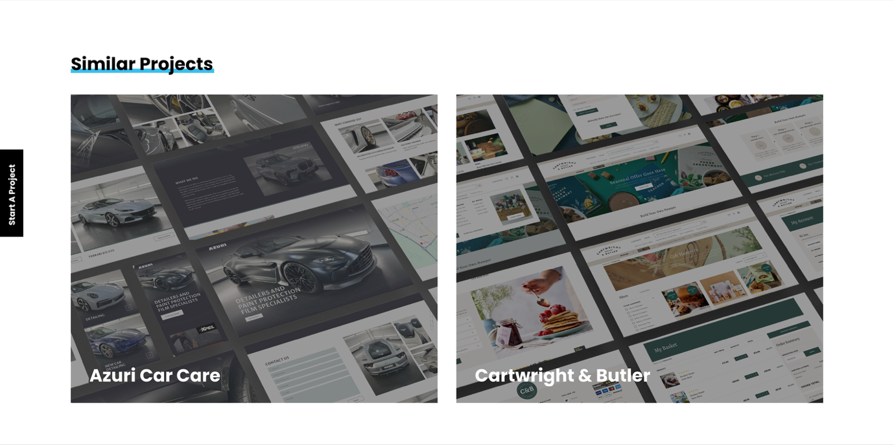Content scrolls up to reveal a read more button - see XD design for example

**News article page**

As user scrolls:

* 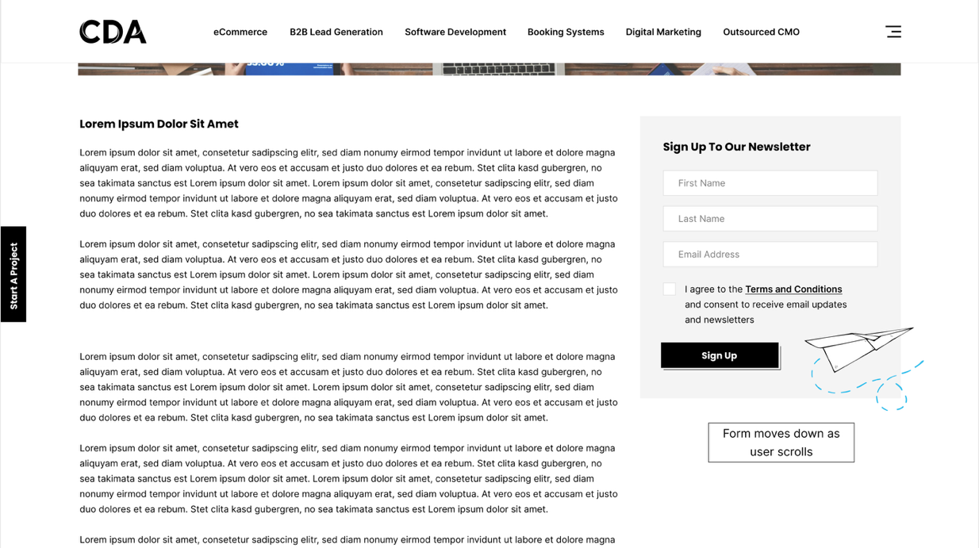Sign up to newsletter block moves down with the pages as the user scrolls, until it reaches the share/next/prev widget where it will stop.